CS2104 Practice problems with solutions. Individual work. Each problem is followed by a solution on the next page: by all means, try to solve the problem on your own before peeking into the solution.

Simplify:

How many integers from 1 to 500 inclusive are divisible by either 2 or 3?

Solution:
- Start simple. Solve the same problem for integers from 1 to 50. In this case you can actually check the answer easily. The idea is to count integers divisible by 2 and by 3 separately, but then exclude even ones from those divisible by 3, since those will have been counted already.
- Full solution: Out of 500 integers, exactly half are divisible by two, which is 250. Now, every 3rd is divisible by 3. Since 500 = 166*3 + 2, we have exactly 166 of those. However, we can’t just add 166 to 250 because ½ of 166 are even, and have already been included in the 250. The remaining 166/2 = 83 are odd, and are OK. So, the total is 250 + 83 = 333.

A symmetry problem.
Four bugs are situated at each vertex of a unit square. Suddenly, each bug begins to chase its counterclockwise neighbor. If the bugs travel at 1 unit per minute, how long will it take for the four bugs to crash into one another?

Solution:
The situation is rotationally symmetric in that there is no one “distinguished” bug. If their starting configuration is that off a square, then they will always maintain that configuration. This is the key insight, believe it or not, and it is a very profitable one!
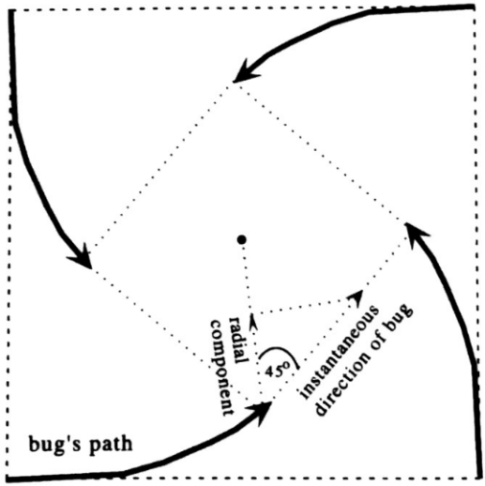
As time progresses, the bugs form a shrinking square that rotates counterclockwise. The center of the square does not move. This center, then, is the only “distinguished” point, so we focus our analysis on it. Many otherwise interactable problems become easy once we shift our focus to the natural frame of reference; in this case we should consider a radial frame of reference, one that rotates with the square. For example, pick one of the bugs (it doesn’t matter which one!), and look at the line segment from the center of the square to the bugs. This segment will rotate counterclockwise, and (more importantly) shrink. When it has shrunk to zero, the bugs will have crashed into one another. How fast is shrinking? Forget about the fact that the line is rotating. From the point of view of this radial line, the bug is always traveling at a 45˚ angle. Since the bug travels at unit speed, its radial velocity component is just 1∙cos45˚ = $\sqrt{2}/2$ units per minute, i.e., the radial line shrinks at this speed. Since the original length of the radial line was $\sqrt{2}/2$, it will take just 1 minute for the bugs to crash.

Another “hidden symmetry” problem. Solve $x^{4}+x^{3}+x^{2}+x+1=0$.

Solution:
While there are other ways of approaching this problem, we will use the symmetry of the coefficients as a starting point to impose yet more symmetry, on the degrees of the terms. Simply divide by $x^{2}$:
$$x^{2}+x+1+\frac{1}{x}+\frac{1}{x^{2}}=0$$
This looks no simpler, but note that now there is more symmetry, for we can collect “like” terms as follows:
$$x^{2}+\frac{1}{x^{2}}+x+\frac{1}{x}+1=0$$
Now make the substitution $u∶=x+\frac{1}{x}$. Note that
$$u^{2}=x^{2}+2+\frac{1}{x^{2}}$$
so (1) becomes $u^{2}-2 +u +1=0$, or $u^{2}+u -1=0$, which has solutions
$$u=\frac{-1±\sqrt{5}}{2}$$
Solving $x+\frac{1}{x}=u$, we get $x^{2}-ux+1=0$, or
$$u=\frac{u±\sqrt{u^{2}-4 }}{2}$$
Putting these together, we have
$$x=\frac{\frac{-1±\sqrt{5}}{2}±\sqrt{{\left(\frac{-1±\sqrt{5}}{2}\right)}^{2}-4}}{2}=\frac{-1±\sqrt{5}±ⅈ\sqrt{10±2\sqrt{5}}}{4}$$
The last few steps are mere "technical details." The two crux moves were to increase the symmetry of the problem and then make the symmetrical substitution $u=x+x^{-1}$.

The Extreme principle:
What is the area between the two concentric circles below? The only thing you know is that a line tangent to the inner circle that bisects the outer circle is 10 units long.

Solution:
First, sketch an example:
10

From here there are two ways to solve it one is to use geometry to find the answer and the other is to look at the extreme case where the answer becomes obvious.
Preferred solution: Use “Extreme case”. Since the only constraint is the tangent line we can change the radii of the inner circle and outer circle as much as we want as long as the tangent line still fits and can bisect the outer circle. So, what happens if we set the inner circle’s radius to 0? Well it becomes a point and the tangent line becomes the diameter of the outer circle. Therefore, the area is πr^2 = 25π.

“Standard” geometry based solution: R^2 = r^2 + 5^2 (from the triangle)
R
r
5
10
Area between = AreaLarge – AreaSmall = $πR^{2}- πr^{2}$ =$π(r^{2}+5^{2})- πr^{2}$
Area between = $πr^{2}+{π5}^{2}- πr^{2}=25π$

Another “extreme principle” problem:
“Play the chord” 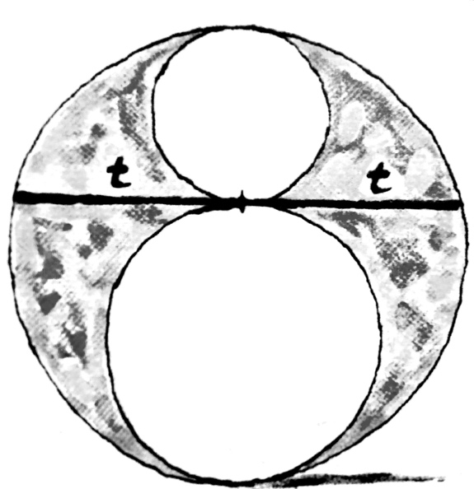

The chord in the above picture equals 2t. Find the shaded area in terms of “t”.

Solution.
Find the solution for an “extreme” case where the answer is obvious. An obvious case is when one of the small circles disappears, and the other one grows to the size of the outside circle. The answer “0” is obvious, but not very useful since it does not depend on t.
Consider another, symmetric case: two small circles are equal. In this case, each has a radius r = t/2, and the large circle has radius t. The shaded area = $πt^{2}-2*π{\left(\frac{t}{2}\right)}^{2}=πt^{2}/2.$
Note: This works because, by the problem statement, the area is a function of t only. So, if we find the function for some special case, it is supposed to be valid in general.

Lateral thinking:

You have two hour-glasses: one measures out 7 mins, the other 11. Hard boiled egg takes 15 mins to cook. Describe an algorithm to make one.

A SOLUTION:
Start both glasses going; when the 7 min one ends, you will have 4 mins. worth of sand left in the 11 min. one. At this point, flip the 7 min one, and wait till the 4 mins are over (the 11 min. one ends) – you will have 3 mins worth of sand left in the 7 min. glass. At this point flip the 11 min. one – once the 3 mins (in the 7 min. one) are over, you will have exactly 8 mins. worth of sand left in the 11 min. glass.
Now you are ready to cook. Start boing the egg, use the remaining sand in the 11 min. glass to count 8 mins, then start the 7 min. glass: 8+7 = 15.
Can you find a more elegant solution?

Invariants:
Can a 5 x 13 rectangle be decomposed into some number of pieces (some may be odd shaped), which may then be reassembled into an 8 x 8 square?

SOLUTION.
No. The area of the figure is an invariant, but it is not conserved in the re-assembly.

